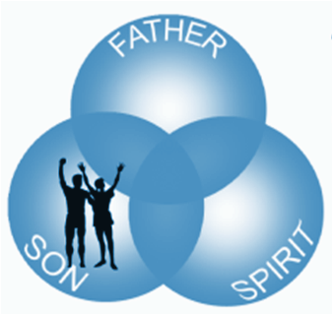
[insert information here
about your congregation]

5. Reconciliation
On the cross, Jesus, the sinless Son of God and Son of man, took upon himself our sins in order, by his sacrifice, to set us free. Because he died, we live. Because he rose from the dead, we have new life forever. Because he ascended, we have a High Priest who is interceding for us in heaven.
Romans 5:8-11 (ESV) …While we were still sinners, Christ died for us. Since, therefore, we have now been justified by his blood, much more shall we be saved by him from the wrath of God. For if, while we were enemies, we were reconciled to God by the death of his Son, much more, now that we are reconciled, shall we be saved by his life. More than that, we also rejoice in God through our Lord Jesus Christ, through whom we have now received reconciliation.

6. Illumination
God the Holy Spirit opens (illuminates) our minds enabling us to trust in this good news of our reconciliation with God through Jesus.
John 14:26 "But the Advocate, the Holy Spirit, whom the Father will send in My name, will teach you all things, and will remind you of everything I have said to you.”
John 16:13-15 “But when he, the Spirit of truth comes, he will guide you into all the truth… He will glorify me because it is from me that he will receive what he will make known to you. All that belongs to the Father is mine. That is why I said the Spirit will receive from me what he will make known to you.”

Here is some good news:
You’re Included!
In a world filled with the heartache of broken relationships, it’s no wonder we long for connection—to love and be loved—to be included. Sadly, when struggles and heartaches mount, many
of us give up on this deep longing.

But there is good news! God offers us a love worth finding and a love worth sharing. At [name of congregation] we experience that love, believing God absolutely and positively has done all it takes for everyone to be included in his love and life with its abundant, fulfilling relationships.
No matter what your background—no matter what you’ve done or what you’ve become, God wants you at His party and has made a way for you to join in.
We cordially invite you to join the party as we worship together at [time] each [day] at [meeting place address].
Come as you are!
7. Participation
The Holy Spirit empowers us to participate in the life of the salvation that God has given us through his Son. We enter this new life with God by placing our trust in Jesus, which means believing the “good news’ (the gospel) about who he is and what he has done on our behalf. In trusting Jesus, we are repenting (changing our mind) about ourselves, about God and about the course of our lives going forward. We are here to help you discover and journey in this new life of participation in God’s love and life. You belong—you are included! We invite you to come and journey with us.
Mark 1:14-15 …Jesus went into Galilee, proclaiming the good news of God. “The time has come,” he said. “The kingdom of God has come near. Repent and believe the good news!”
Acts 2:38 Peter replied, “Repent and be baptized, every one of you, in the name of Jesus Christ for the forgiveness of your sins. And you will receive the gift of the Holy Spirit.”
a
Perhaps you remember the TV sitcom Maude. Maude, played by actress Bea Arthur, was married to Walter who nearly every episode would do something that angered Maude.
Her typical reaction would be to declare, Walter—God will get you for that!
- Trinity
Despite Maude’s opinion about God (one held, sadly, by many) God is not out to get you. The good news is that God (who is Father, Son and Holy Spirit) is love, and He loves you—he always has! And there is nothing you have ever done, or has been done to you, that can keep him from loving you. How can that be true? Find out by reading the rest of this brochure and joining with us as, together, we learn more about who God is and what he has done for us.
1 John 4:16 And so we know and rely on the love God has for us. God is love. Whoever lives in love lives in God, and God in them.
John 3:16-17 For God so loved the world that he gave his one and only Son, that whoever believes in him shall not perish but have eternal life. For God did not send his Son into the world to condemn the world, but to save the world through him.
- Adoption
Long before you were born, God the Father, in love and for love, arranged to make you part of his family so you could live with him forever. He did this by choosing (adopting) you, and he did that before you ever did anything good or bad.
Ephesians 1:3-8 Praise be to the God and Father of our Lord Jesus Christ, who has blessed us in the heavenly realms with every spiritual blessing in Christ. For he chose us in him before the creation of the world to be holy and blameless in his sight. In love he predestined us for adoption to sonship through Jesus Christ, in accordance with his pleasure and will—to the praise of his glorious grace, which he has freely given us in the One he loves. In him we have redemption through his blood, the forgiveness of sins, in accordance with the riches of God’s grace that he lavished on us.
- Alienation
But there is a problem. Wanting to get our own way and to go our own way, every one of us, to one extent or another, shut God out of our lives. We all have been alienated from God.
Colossians 1:21-22 Once you were alienated from God and were enemies in your minds because of your evil behavior. But now he has reconciled you by Christ’s physical body through death to present you holy in his sight, without blemish and free from accusation…

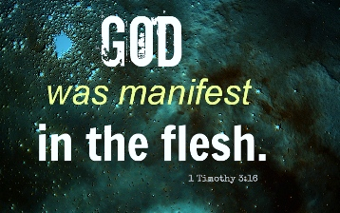

- Incarnation
Knowing full well we would be alienated from him, God initiated his plan to deal with the underlying problem, which is sin. His plan centered on Jesus, the Son of God, becoming human through what is known as the Incarnation.
1 Timothy 3:16 Beyond all question, the mystery from which true godliness springs is great: He [Jesus] appeared in the flesh, was vindicated by the Spirit, was seen by angels, was preached among the nations, was believed on in the world, was taken up in glory.

2 Timothy 1:9-10 He has saved us and called us to a holy life—not because of anything we have done but because of his own purpose and grace. This grace was given us in Christ Jesus before the beginning of time, but it has now been revealed through the appearing of our Savior, Christ Jesus, who has destroyed death and has brought life and immortality to light through the gospel.

