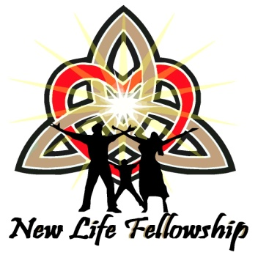
New Life Fellowship Good News Festival Registration Form
"The Father Loves and Likes You!" Fest!
October 23rd - 25th, 2015 at:
Holiday Inn Oceanfront Resort Hotel
6000 Coastal Highway, Ocean City, MD. 21842
Hotel Registration: Tel: 1800-837-3588 or http://tinyurl.com/mt83blo

To Register:
Complete this form, include payment, and return to New Life Fellowship at the address below. Registration Cost covers the meetings, The Great Dance activity plus food, and a Full Hot Buffet Breakfast on Sunday. Registration closes on October 16th, 2015. Cancellations received by September 1st 2015 will receive a refund. After that date, there are no refunds. Detailed information about the Festival is available on our New Life Fellowship Website (www.newlifebaltimore.org/events) or on the Grace Communion International Website (www.gci.org/events) or you can call at the number below.
New Life Fellowship of Baltimore, Maryland
P.O. Box 1417
Owings Mills, MD 21117
Any questions can be directed to Karen Harris at: 410-622-4824

_______________________________________________________________________________________________________
LAST NAME FIRST NAME MIDDLE NAME

_______________________________________________________________________________________________________
ADDRESS PHONE NUMBER EMAIL ADDRESS

I am registering the following person/s ( Include yourself below):
Adults 17 and older- $70.00: 1. 3.
2. 4.
TOTAL ADULTS: ---------
_________________________________________________________________________________________________________
Teens 12-16- $50.00: 1. 3.
2. 4.
TOTAL TEENS: ---------
_________________________________________________________________________________________________________
Kids 4-11- $40.00: 1. 3.
2. 4.
TOTAL KIDS: ---------
_________________________________________________________________________________________________________
Kids 3 and under- Free: 1. 3.
2. 4.
TOTAL KIDS 3 and under: ----------

Total Payment Submitted: $ ---------------

