Our Ministries
Our ministries are projects and programs we pursue to fulfill our objectives.
In pursuit of the overall goal of all Christians (to proclaim the gospel of Jesus Christ) and in fulfillment of our mission as part of the Body of Christ, Grace Communion International supports the following ministries:
Collective
· Local church congregations shepherded by full-time and volunteer pastors.
· Worship services each week and on annual festivals and holidays.
· Planting new congregations.
· Print and broadcast evangelism.
· Ambassador College of Christian Ministry and Grace Communion Seminary.
· Ongoing education for both professional and lay ministers.
· Youth ministries, children’s church programs and summer camps.

Individual Ministries
· Church and community-service ministries offered by members to the glory and honor of Jesus Christ.
· Christian music and drama.
· Coordinating and participating in small-group ministries, including home Bible studies, prayer meetings, children’s programs, youth and other group ministries.
· A commitment to spiritual growth through regular prayer, Bible study, meditation, fellowship, worship, and other spiritual disciplines.

For more information, consult our website: www.gci.org or write: Grace Communion International, P.O. Box 5005, Glendora, CA 91740-0730.

Grace Communion
International

Our Mission
and Ministries

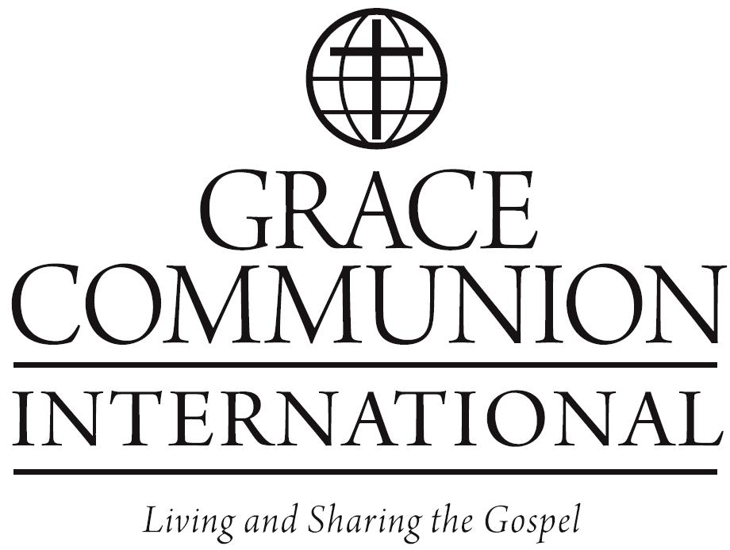

Our Mission:
Living and sharing the gospel

Grace Communion International is committed to living and sharing the good news of what God has done through Jesus Christ.

We seek to fulfill this mission by:
- Building healthy, Christ-centered congregations that are sanctuaries of worship, friendship, and nurturing pastoral care.
- Providing sound biblical teaching through congregations, media, and personal outreach in relevant, meaningful forms for people of diverse backgrounds and ages.
- Expressing the love of God to all through the work of the Holy Spirit in our lives.
- Equipping people for Christian service so that the gospel can be known, understood, and experienced._
- Sharing in the work of the gospel with the broader Christian community, acknowledging that we can learn from one another and that Christ’s love goes beyond denominational boundaries.

As a result of our heritage and tradition as a church, we offer these spiritual gifts and distinctives:
· Emphasis on the absolute sovereignty and centrality of Jesus Christ in all our worship.
· Insistence upon salvation by grace through faith.
· Reverence and commitment to God’s Holy Scriptures, the inspired foundation of Christian faith and practice.
· Willingness to be continually transformed by the Holy Spirit, realizing that spiritual growth and sanctification constantly demand repentance and change.
· Belief in the certainty and importance of the second coming of our Lord and Savior.
· Committed members who faithfully follow Jesus Christ and who devote themselves to proclaiming his gospel to all the world.
· A high view of the sanctity and value of the family structure within the Body of Christ.
· Responsible stewardship of, and accountability for, the financial resources God makes available to us, through the generous sacrifices and contributions of our fellow laborers, for the proclamation of Jesus Christ’s message.

Our Objectives
These represent priorities related to the fulfillment of our mission.
· To empower believers to evangelize individually and collectively.
· To provide both full-time and volunteer ministry to serve believers through pastoring, teaching, counseling and leadership.
· To plant and maintain local congregations for the nurturing and growth of believers and to provide a collaborative presence as lights to the community.
· To maintain an administrative center for the organization and support of ministry, congregations and other collective evangelical efforts.
· To evangelize and teach through printed and electronic media.
· To offer Christ-centered education, including preparation and continuing education for the ministry.
· To provide venues for collective regional, national and international worship and evangelism.
· To provide Christ-centered education and recreational programs.

